DRAFT UI

HOME PAGE (DASHBOARD)

<https://www.figma.com/file/GhuFnSZkagyzrFqgVNRe77/DRAFT?type=design&node-id=1%3A4&t=PxRmYlGa5Akq0uEE-1>

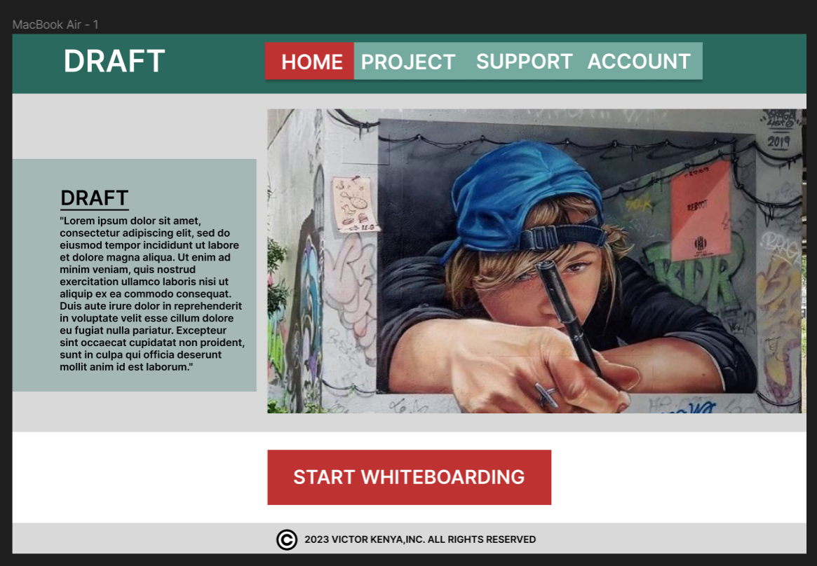

PROJECTS PAGE

<https://www.figma.com/file/GhuFnSZkagyzrFqgVNRe77/Untitled?type=design&node-id=0%3A1&t=QbT7HNi8PQqZtFEM-1>

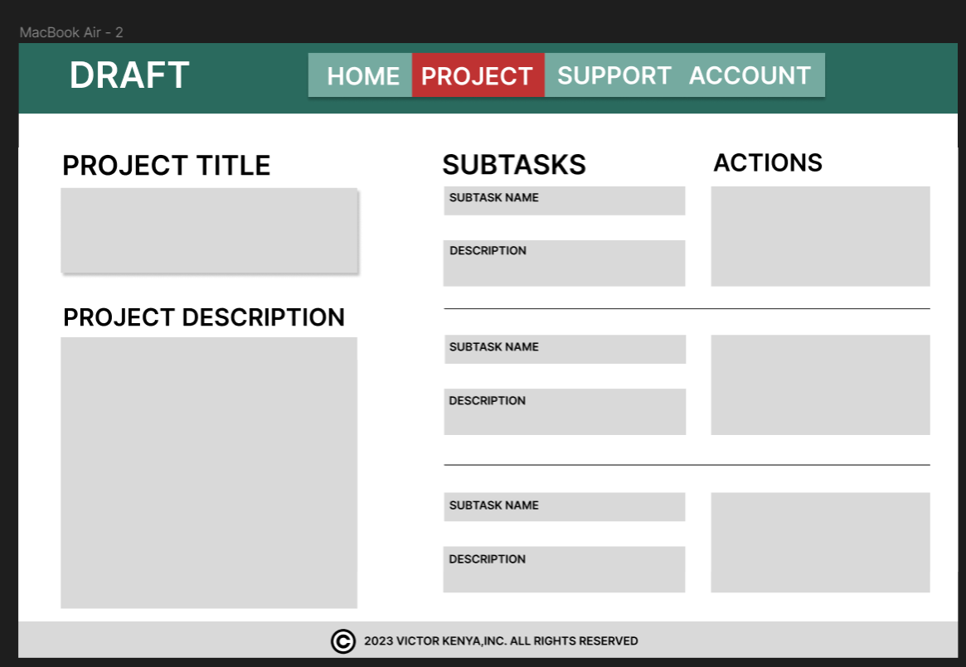

SUPPORT PAGE

<https://www.figma.com/file/GhuFnSZkagyzrFqgVNRe77/Untitled?type=design&node-id=0%3A1&t=QbT7HNi8PQqZtFEM-1>

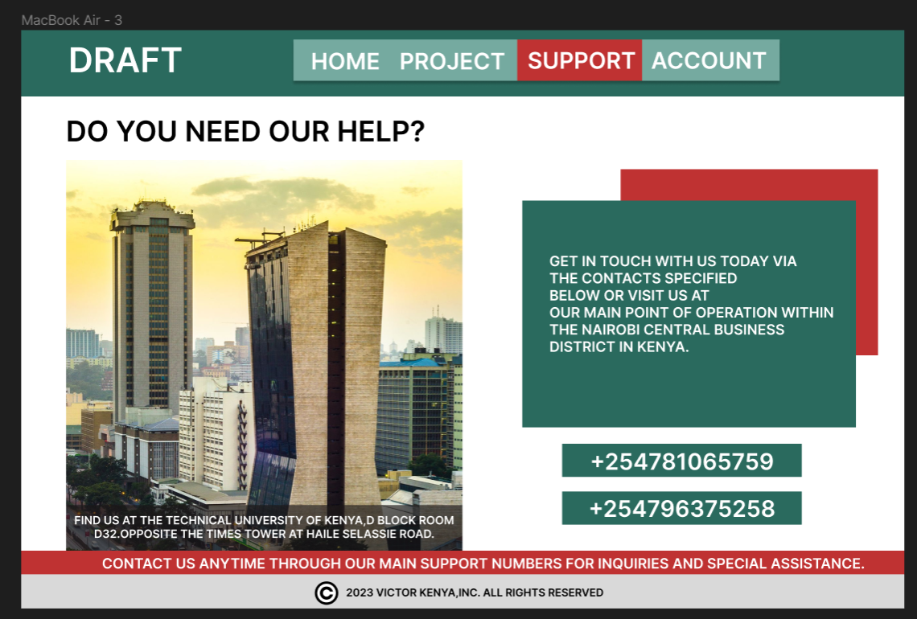

ACCOUNT PAGE

<https://www.figma.com/file/GhuFnSZkagyzrFqgVNRe77/Untitled?type=design&node-id=0%3A1&t=QbT7HNi8PQqZtFEM-1>

